**MONGO DB**

**.insert()**

In MongoDB, the**db.collection.insert()** method is used to add or insert new documents into a collection in your database.

Eg:

**Input:**



**Output:**

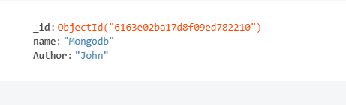

**Upsert**

There are also two methods **db.collection.update()** method and **db.collection.save()** method used for the same purpose. These methods add new documents through an operation called **upsert**.

**Upsert** is an operation that performs either an update of existing document or an insert of new document if the document to modify does not exist.

Eg:

**Input(modified)**



**Output(modified):**

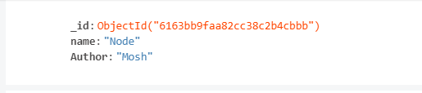

**Input(inserted):**

**.find()**

If the insertion is successful, we can view the inserted document by the following query.

**db.collections.find()**

eg:

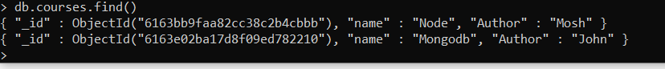

**Multiple Doccuments**

If we want to insert multiple documents in a collection ,we have to pass an array of documents to the **db.collection.insert()** method.

Eg:

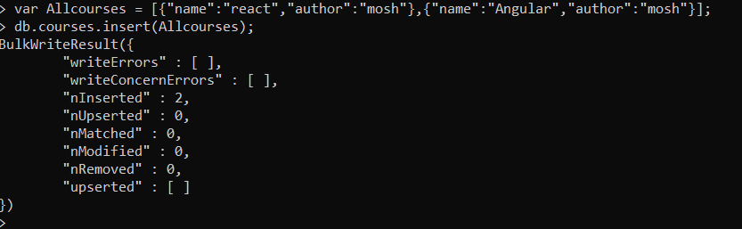

Output:

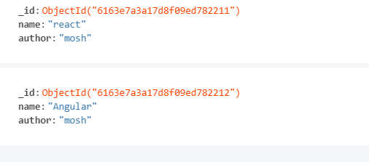

**.aggregate()**

**$group**

Group is used to grouping together items into required subsets on a particular criterion.  We can also use groups to perform operations across a common field in all documents, such as calculating the sum of a set of transactions and counting documents.

Eg:

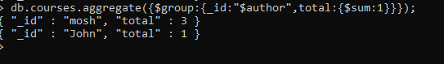

**$match**

Filters the documents to pass only the documents that match the specified condition(s) to the next pipeline stage.

Eg:

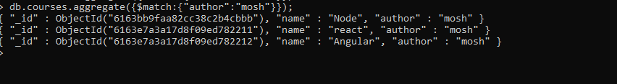

Created Transactions collection and inserted the values as follows:

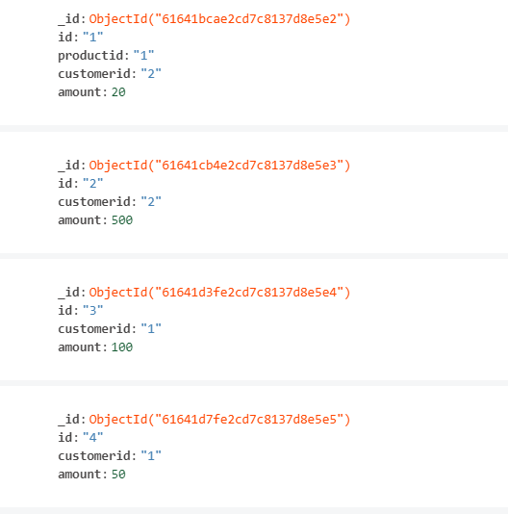

eg: total amount transacted by customer1:



eg: average amount transacted by customer1:



eg: minimum amount transacted by customer2:



eg: maximum amount transacted by customer2:

